Simple crystals | Type | Size  (µm) | Size  range  (µm)
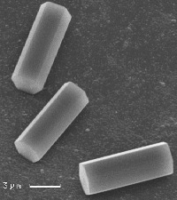 | Small  column | 8 | 1-400
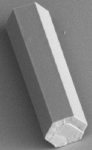 | Large  column | 250 | 1-400
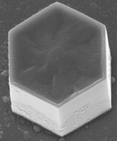 | Short  column  (thick  plate) | 27 | 10-300
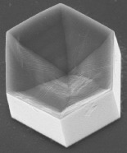 | Hopper  column | 30 | 20-120
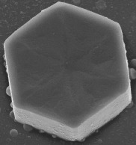 | Small  plate | 30 | 3-200
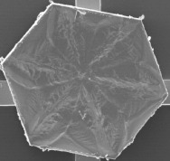 | Large  plate | 90 | 3-200
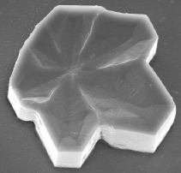 | Sector  plate | 50
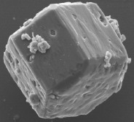 | Rough  crystal | 50

